UNIVERSITY OF WAH (UOW)

DEPARTMENT OF COMPUTER SCIENCE



COURSE TITLE: INTRO TO INFORMATION SECURITY

COURSE CODE: CS – 251 L

SUBMITTED TO: MS. WASIFA KANWAL

SUBMITTED BY: SAADI SAFDAR

REG #: UW-24-CS-BS-088

BSCS 3RD B

FINAL LAB SESSIONAL

Q1:
time = int(input("Enter time (0-23): "))
day_type = input("Enter day type (weekday/weekend): ").lower()
balance = float(input("Enter card balance: "))
decision = ""
path = ""
if balance < 10:
decision = "No Discount"
path = "Low balance denial: Balance is below 10."
elif day_type == "weekend":
if (12 <= time <= 14) or (18 <= time <= 20):
decision = "Partial Discount"
path = "Weekend rule: Peak hours (12-14 or 18-20) override full discount."
else:
decision = "Full Discount"
path = "Weekend rule: Standard weekend hours allow full discount."
else:
if 7 <= time <= 10:
if balance > 50:
decision = "Full Discount"
path = "Weekday morning: Balance > 50 allows full discount."
else:
decision = "No Discount"
path = "Weekday morning: Balance <= 50 denies discount."
elif 12 <= time <= 14 or 18 <= time <= 20:
decision = "Partial Discount"
path = "Weekday peak: Lunch or dinner rush receives partial discount."
else:
decision = "No Discount"
path = "Weekday standard: No active discount window."
print(f"Decision: {decision}")
print(f"Logical Path: {path}")

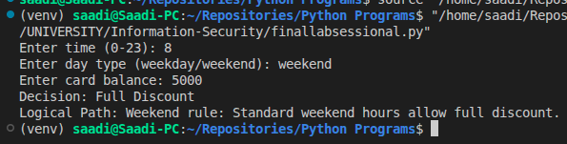

Q2:
violations = 0
threshold = 3
log = []
while violations < threshold:
entry = input("Enter violations at checkpoint (comma separated) or 'exit': ")
if entry.lower() == 'exit':
break
current_checks = entry.split(',')
for check in current_checks:
check = check.strip().lower()
if violations >= threshold:
log.append(f"Skipped {check}: Fine threshold already reached.")
continue
if check in ["speed", "signal", "zone"]:
violations += 1
log.append(f"Check: {check} - Violation recorded.")
else:
log.append(f"Check: {check} - No violation.")
final_status = "Critical - Fine Threshold Reached" if violations >= threshold else "Active - Below Threshold"
print("\n--- Processing Log ---")
for item in log:
print(item)
print(f"\nFinal Status: {final_status}")
print(f"Total Violations: {violations}")

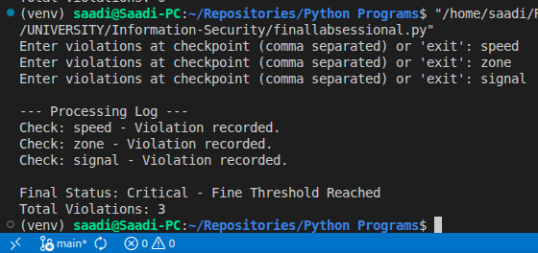

Q3:
flats_data = {
"Flat A": [15.5, -2.0, 18.2, 500.0, 16.1],
"Flat B": [10.1, 12.5, 11.2, 13.0, 10.5],
"Flat C": [5.0, 25.0, 4.5, 28.0, 5.2]
}
summary = {}
most_inconsistent_flat = ""
max_variance = -1
for flat, readings in flats_data.items():
valid_readings = []
for r in readings:
if 0 <= r <= 100:
valid_readings.append(r)
if not valid_readings:
continue
avg_usage = sum(valid_readings) / len(valid_readings)
peak_usage = max(valid_readings)
diffs = [abs(valid_readings[i] - valid_readings[i-1]) for i in range(1, len(valid_readings))]
variance = sum(diffs) / len(diffs) if diffs else 0
summary[flat] = {"Average": avg_usage, "Peak": peak_usage}
if variance > max_variance:
max_variance = variance
most_inconsistent_flat = flat
print("--- Building Summary Report ---")
for flat, stats in summary.items():
print(f"{flat} -> Average: {stats['Average']:.2f} units, Peak: {stats['Peak']:.2f} units")
print(f"\nFlat with most inconsistent pattern: {most_inconsistent_flat}")

